Accounting and Finance Requirements Specification

Version 1.0

2018

Table of Contents
1. Executive Summary 3
1.1 Project Overview 3
1.2 Purpose and Scope of this Specification 3
2. Product/Service Description 3
2.1 Product Context 3
2.2 User Characteristics 3
2.3 Assumptions 3
2.4 Constraints 3
2.5 Dependencies 4
3. Requirements 4
3.1 Functional Requirements 5
3.2 User Interface Requirements 5
3.3 Usability 5
3.4 Performance 6
3.4.1 Capacity 6
3.4.2 Availability 6
3.4.3 Latency 6
3.5 Manageability/Maintainability 6
3.5.1 Monitoring 6
3.5.2 Maintenance 6
3.5.3 Operations 6
3.6 System Interface/Integration 7
3.6.1 Network and Hardware Interfaces 7
3.6.2 Systems Interfaces 7
3.7 Security 8
3.7.1 Protection 8
3.7.2 Authorization and Authentication 8
3.8 Data Management 8
3.9 Standards Compliance 8
3.10 Portability 8
4. User Scenarios/Use Cases 9
5. Deleted or Deferred Requirements 9
6. Requirements Confirmation/Stakeholder sign-off 10
APPENDIX 11
Appendix A. Definitions, Acronyms, and Abbreviations 11
Appendix B. References 11
Appendix C. Requirements Traceability Matrix 11
Appendix D. Organizing the Requirements 13

Executive Summary

Project Overview
.The Accounting and Finance is an online integrated financial accounting system that records, monitors and maintains all accounting and financial transactions of the organization. The Accounting and finance system provides a complete financial budgeting and managerial reporting system that, due to its flexibility, is able to meet the financial reporting needs of the organization.
The Accounting and Finance system is a system of collecting, storing and processing financial and accounting data that are used by decision makers. This system is generally a web-based method for tracking accounting activity. Accounting and Finance are designed to support all accounting functions and activities including auditing, financial accounting and reporting managerial and tax.

Purpose and Scope of this Specification
The purpose of the system is to collect, store and process financial and accounting data, to accumulate and report on financial information about a firm’s performance, financial position and cash flows of system. To also manage a business’ records to keep track of income, expenses and other financial activities
In scope
- Produce calculation for annualization, final pay that are definitive and irrefutable
- Preparing employee’s payroll including calculation of salaries, contribution for social insurance, health insurance, unemployment insurance and personal income tax.
- Preparation of corresponding payment orders and transfer orders for employees salaries
- Preparing and filling monthly and annual salary returns
- Registration/ deregistration of employees with relevant social institution
- Preparation of calculation for other contract per client request
Out of Scope
- Accepting/hiring employees
- Product supplying and Delivery
- Direct collecting of payments from customer
- Managing employees
- Viewing products and it’s price
- Storing of products
- Advertising of products

Product/Service Description
This study involves everything that has to do with the payment of employees and the filing of employment taxes. This includes keeping track of hours, calculating wages, withholding taxes and other deductions, printing and delivering checks and paying employment taxes to the government. These services automatically calculates how much employees should be paid each pay period and can withhold employee taxes, file quarterly payroll tax reports and pay tax with holdings to the proper state and federal agencies. Also it’s goal is to provide record and analyze financial information of clients in timely and accurate manner. Well organized financial record, ensure that business operations well run more efficiently and the business performs the best possible accounting practices at any given time.

Product Context
The resulting financial reports can be used internally by management or externally by management or externally by other interested parties including investors, creditors and tax authorities. This system is like calculating all money on the company, such as giving a salary to the employee and managing the money involve in the company. This system is giving the employee an ease on work, rather than manually computing.

User Characteristics
Type of user who will be using the product. Profiles should include:
- Payroll admin
No other has access to any specific payroll details. If a user’s rule allows them to view reports, they still won’t be able to access payroll reports without Payroll admin access. They may be able to view read-only totals related to payroll in other reports, but won’t be able to see any employee payment details.

Assumptions
They provide structure to how business transactions are recorded. If any of these assumptions are not true, it may be necessary to alter the financial information produced by a business and reported in its financial statements. Accounting allows a company's activities to be divided into informal time periods so it can produce financial information which individuals can use to make decision

Constraints
Describe any items that will constrain the design options, including
- parallel operation with an old system (Incompatibility with other system)
- Audit functions (audit trail, log files, etc.)
- The employee has no account and they only using their employee ID for the attendance
- Non-compliant features
- Incomplete features
- Too much features

Dependencies
List dependencies that affect the requirements.
- The system is no hash security on database.
- The system needs data from human resource department for the employee
- The system needs data from the supply chain department and Marketing and sales for the product.

Requirements

Functional Requirements
Function involves balancing and reconciling payroll data and depositing and reporting taxes (Take care of wage deductions, record ,keeping and verifying the reliability of data).
Req# | Requirement | Comments | Priority | Date Rvwd | Reviewed / Approved
BR_05 | The system should associate the salary. | Business Process
BR_03 | The system must be able to accommodate your employees and their various working hours. | Accuracy
BR_04 | The system must be set up for more complex operation such as deduction for tax and benefits purposes.
BR_ | The system must be able to generate pay slip
BR_ | The system can be used to keep detailed and accurate record (such as number of hours worked, salaries and wages, bonuses and commission and deductions)
BR_08 | The system should record the entire treasury and cash management | Business Process
BR_10 | The system should manage the deduction in every 1 month like sss, pag-ibig and tax. | Business Process
BR_ | The system should monitor how much employee take off work (leaves), use sick days or absences even tardiness.
BR_16 | The system should list the expenses, accounts receivable, accounts payable, financial reporting and financial control.
BR_ | The system stored necessary data such employee information, all payments and deductions into database.
BR_ | Payroll reports generate reports for specific payroll and general reports demand.
BR_18 | The system should monitor of annual budget. | Monitoring

User Interface Requirements
- Login screen
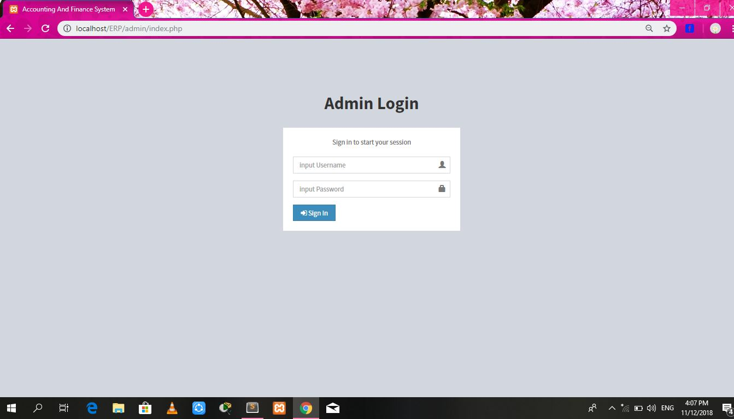

- Dashboard/Monthly attendance report
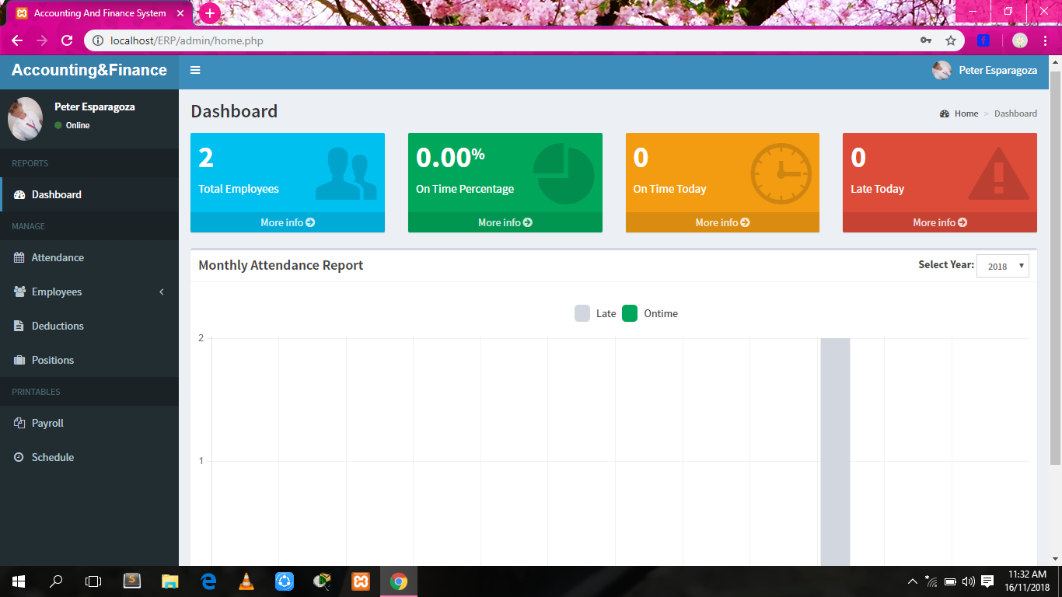

- Employee Salary Details
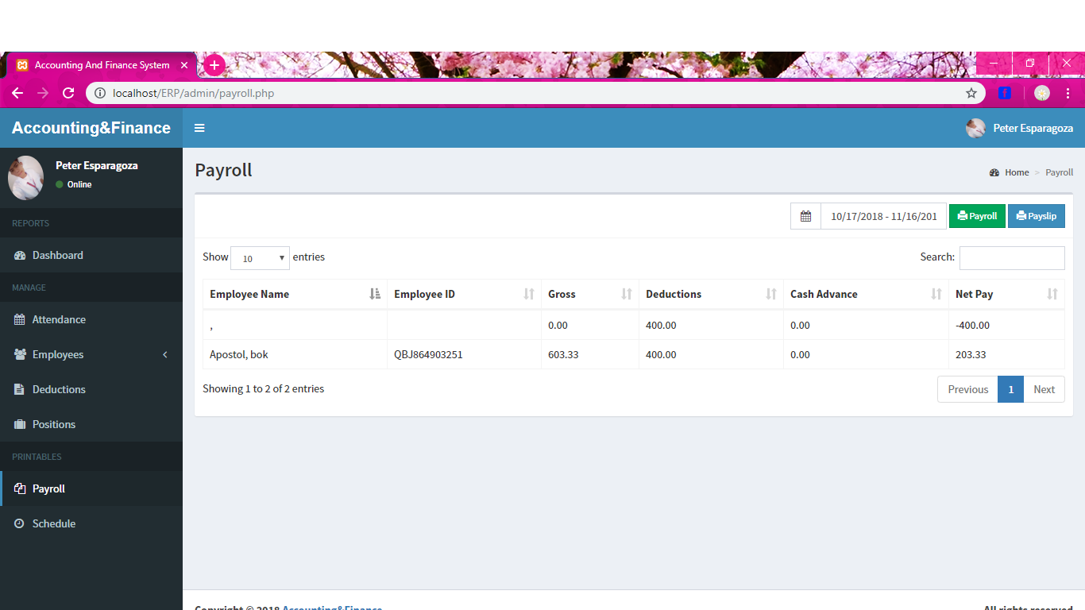

- Employee Deductions Details
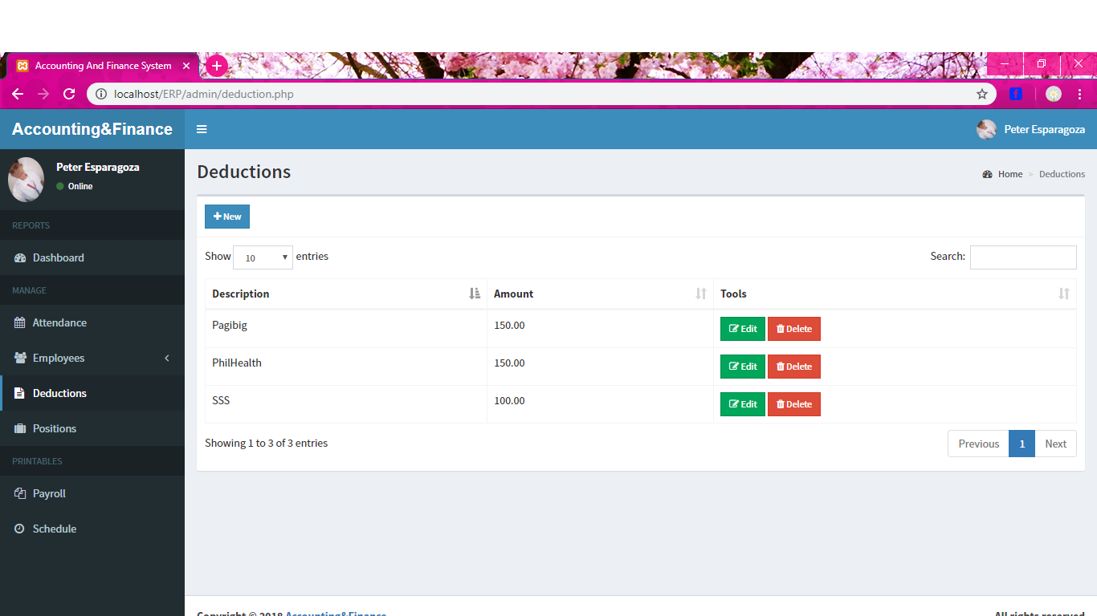
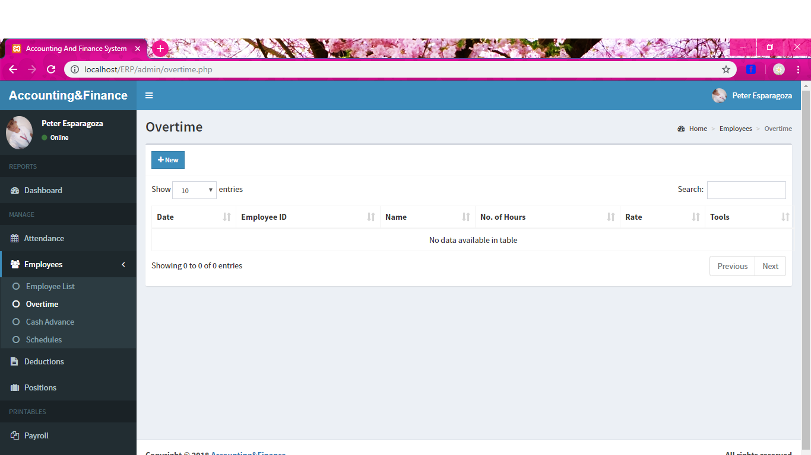

- Cash advance
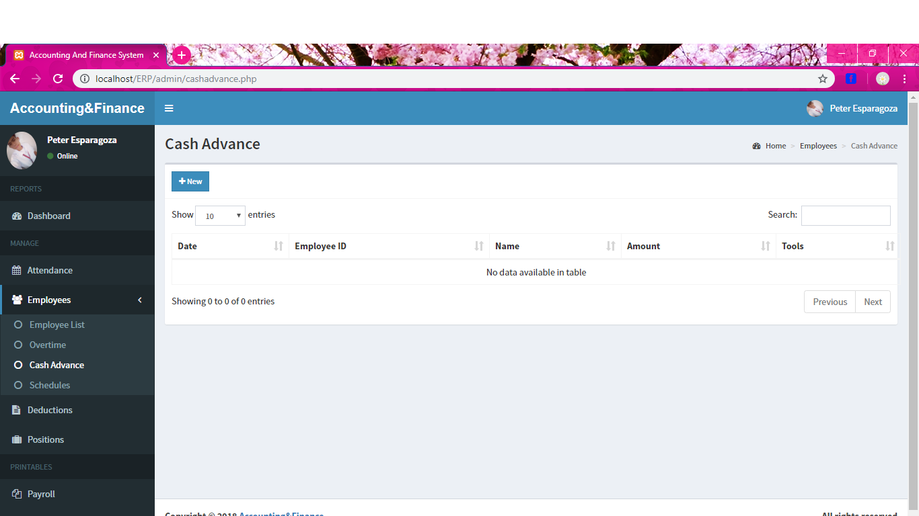

- Schedules
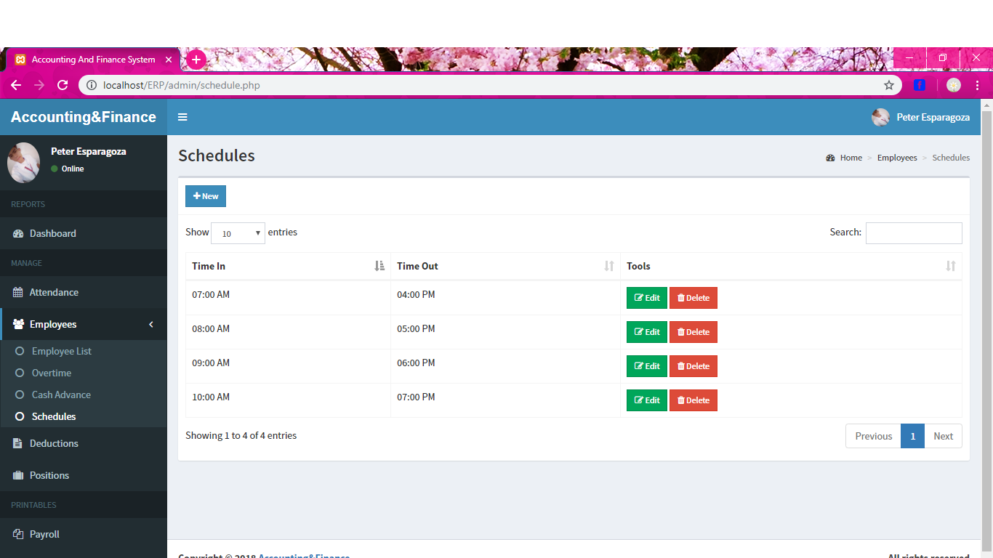

- Generate Pay slip
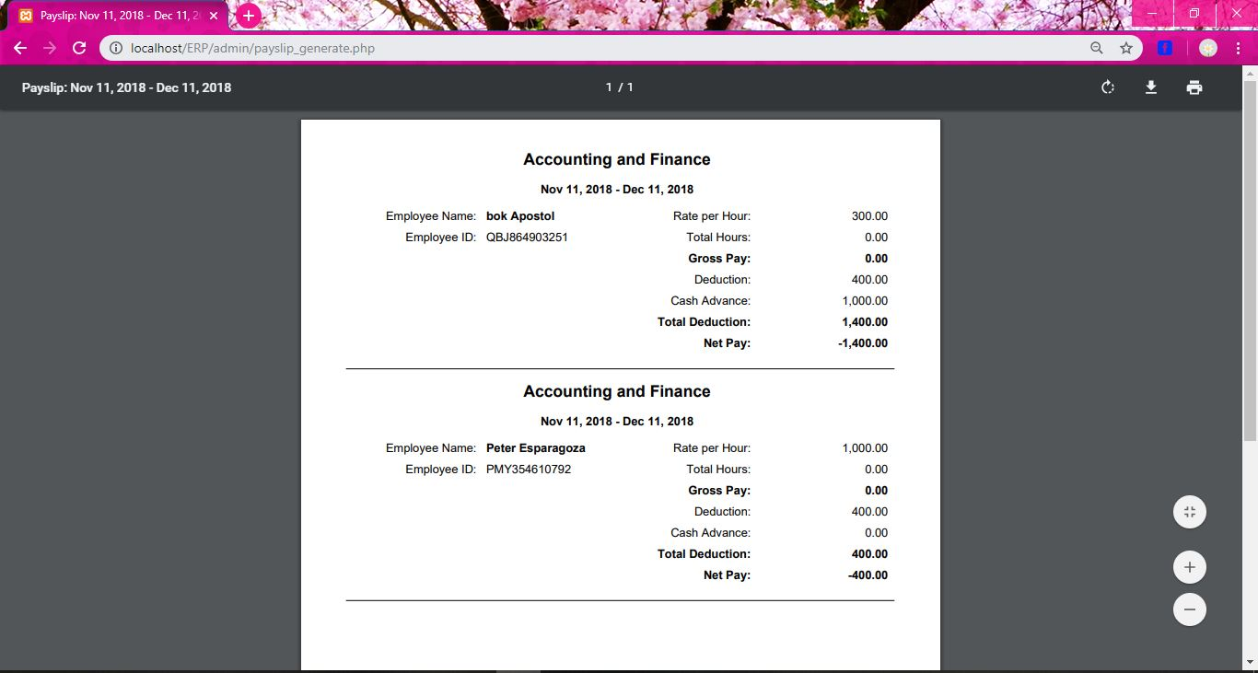

Usability
Include any specific usability requirements
- To provide human connection through online communication.
- Offer the basic level process of payroll for customer needs.
- Minimize manual errors and cycle times.
- It offers benefits such as efficient management of staff data, secure financial transactions, and detailed reports on employee payroll.

Performance
System can withstand even though many number of users requested desired service and access is given to the only registered users who requires the services of viewing, updating etc. It can withstand preload. The system has the flexibility to save and provide complete details of unlimited number of employees. It has automated processes to manage employee schedules, process accurate salaries, generate and maintain pay slips, pay sheets, pay summaries, salary advancements, fixed allowance and deductions, monthly allowance and deductions, over time calculations, no pay deduction, payee tax report, no pay detailed report, late minutes deduction report and others.

Capacity
There’s no measurable capacity in the system of financial accounting, only the admin can access and input some data of the user in the system. All the data of the human resource are also save in our system. No storage data limitations: unlimited capacity for employees, earnings, deductions, companies, users, and years of history.

Availability
Include specific and measurable requirements for:
- Identify the income of every items delivered.
- Record of every payment of each employee.
- Record of every paid item of each customer.
- List of customers and employee
- Efficient invoicing system.
- Every function load for 5 seconds

Latency
- In listing every customer’s payment we have 5 days to review the customer’s payment information.
- In listing every employee’s salary we have 5 days to settle.
- Selecting the schedule, every week or once month to pay the employee.
- Responsible for reporting every hour of employee.
- In recording every employee’s deduction in their monthly payment we have 1 month to review

Manageability/Maintainability
All the individual process for payroll information will be secured by the admin. Updating employee payroll record and dealing withholding information will be maintained.

Monitoring
Include any requirements for product or service health monitoring, failure conditions, error detection, logging, and correction. This system may produce the requirement that needed of all customers, employee and also the department. All the reports about finance will be saved and be secured on the database, it also performed a payroll report and pay slip report for those who needed the services. The accounting financial may monitor the entire user that logging in the system, this services help the user to save all the information that they save in the database and it’s secured by the department. The basic report that company needs to produce the balance sheet and the profit/loss statement. In every month an aged debtor’s trial balance should be prepared, so that it can keep track of all the customers who owe them money. They must keep the track of irregular accounts and follow up diligently with defaulters to get back their money.
- Recording of the employees.
- Identify employee’s monthly salary.
- Recording data to another department.
- Record of customer’s payment in each item.
- Total payment of income in a week, month or in a year.

Maintenance
Documented system maintainability objectives, policies and standard are communicated to authorized users. The cost must incurred to ensure that an asset continues to operate. Creating and maintenance a company should have spreadsheet list was an exercise in futility. Human errors proliferated, version control issues were common and the back and forth emails needed to ensure accuracy were never-ending. All changes to account attributes codes and other account specific information must be approved by the financial services.System need to maintain the functionality of each module and establish requirement and task to accomplish for achieving restoring and maintaining operational capability for the features of the system. We need to maintain the system to keep your company in compliance with the law. Without good accounting you could violate any number of laws, such as not paying the right amount of taxes. The sloppiness of poor accounting can also cause you to overlook many minor details that collectively keep a business on the level, like carrying out facility improvements to comply with safety laws. Additionally, if you ever find yourself under legal scrutiny -- and many businesses eventually do -- having poor financial records can create a lot of unnecessary trouble

Operations
Specify any normal and special operations required by the user, including:
- Planning operation accounting use the history trends to predict the future performance.
- Directing activities involve oversight of employee and help the company reach its financial goals.
- The regulatory agencies and investors now expect business to have a backup solutions and comprehensive record-keeping practices.
- The procedure are regularly enhanced and tested to address various emerging risk.
- Analyzing the balance sheet and reviews current problem areas or inefficiencies.

System Interface/Integration
The inventory requirements determined by the system pass through to the inventory system to check availability, then to the procurement system to create a purchase order and on to the accounts payable system for payment. Making a plan for consolidation that areas focuses for finance and accounting integration between the entities include treasury and cash flow, controls and compliance, financial planning and analysis, procurement, invoicing, assets and liabilities, accounts payable, accounts receivable and tax. Analysis of seller company financial practices, this is an aspect that calculate the revenue, valuation of inventory and closing cycles, or for more complex issues. The financial data gathered from the seller company needs to be organized in one secured place.

Network and Hardware Interfaces
- Server configuration
- Minimum 2GB hard disk
- RAM 512mb
- Windows with apache preloaded
- Client configuration
- A terminal with inter explorer and printer

Systems Interfaces
Every department will create and sent files that will be imported to payroll for calculation. The requirements below document the file specification and data transfer process.
Batch Totals Record
The batch totals record can be placed at the beginning, in the middle, or at the end of the file.
The batch totals record contains the following:
- Record Type (no. of hours)
- Total Amount of Payroll
- Total number of detail records
- Total deduction amount
Detail Records
Each row in the Filename file contains the following fields, comma-delimited and encased in double-quotes where the data includes commas or spaces:
- Employee Id
- Cash Advance
- Record Type
- Attendance
- Process Date (MMDDYY)
- Employee Lists
- Deduction List
- Schedule
- Amount Payroll
- Total Amount Sign

Security
Sensitive data is protected from unwanted access by user’s appropriate technology and implementing strict users-access criteria. Companies in this situation also struggles secure data, a growing concern given some of high profile cases reported in the media involving lost, breached and stolen data

Protection
Specify the factors that will protect the system from malicious or accidental access, modification, disclosure, destruction, or misuse.
- activity logging (user should update their password on a regular basis)
- historical data sets (Back up)
- Payroll system updates applied to payroll software in timely fashion
- restrictions on inter module communications
- data integrity checks
- System security is part of overall security policy to patrol threats through anti-virus and anti-malware software

Authorization and Authentication
As for the payroll system, we merely want to allow only those authentic users (for authorization) with username and password that require user for authentication to prove their identity. Through the use of user identification numbers and passwords, relevant employees can access the payroll database. Access should be restricted to the appropriate personnel. For example, if your human resources and payroll departments are separate, but they share the same database, the other department should not have access to paycheck processing and the payroll department should not have access to benefits administration.

Data Management
Specify the requirements for any information that is to be placed into a database, including
- Billing
- Deduction and leaves
- Human resources record
- Supply chain management record
- Accounts receivable
- Accounts payable
- Bank reconciliation
- Worker’s compensation and risk management
- Benefits administration
- Tax filling
- Unemployment reporting

Standards Compliance
The consolidated activities involved in the production of payroll, capturing data and controlling it along with the calculation of allowances, deduction, benefits and the net wages. The organization who comply to these standards who’s responsible for management of payroll.

Portability
- The portability of the system is PHP, CSS, java script.
- The percentage of the component is depending to the system that inquires host.
- The proven portable language is PHP, CSS, java script.
- The integrated system was offline.
- The particular operating system windows 7-10.

User Scenarios/Use Cases
Provide a summary of the major functions that the product will perform. Organize the functions to be understandable to the customer or a first time reader. Include use cases and business scenarios, or provide a link to a separate document (or documents). A business scenario:
- Describes a significant business need
- Identifies, documents, and ranks the problem that is driving the scenario
- Describes the business and technical environment that will resolve the problem
- States the desired objectives
- Shows the “Actors” and where they fit in the business model
- Is specific, and measurable, and uses clear metrics for success

Deleted or Deferred Requirements
Identify any requirements that have been deleted after approval or that may be delayed until future versions of the system. For example:
Req# | Business Requirement | Status | Comments | Pri | Date Rvwd | SME Reviewed /Approved
BR_LR_01 | The system should validate the relationship between Bargaining Unit/Location and Job Class. | April 2005: Deleted.  This requirement has been replaced by BR_LR_036 and BR_CC_33. | Business Process = “Assigning a Bargaining Unit to an Appointment” | 1 | 7/13/04 | Bob Dylan, Mick Jagger
BR_LR_02 | The system should validate that the supervisor indicator is correct according to job class.  Deferred to Phase 2B: 3/29/2005 | April 2005: Deferred to Phase 2B. | Business Process = “Assigning a Bargaining Unit to an Appointment” | 3 | 7/13/04 | Bob Dylan, Mick Jagger
BR_LR_03 | The system should derive the bargaining unit code, union code, and supervisor indicator from the job class code and location. | April 2005: Deleted  Replaced by BR_LR_16 and BR_LR_17. | Business Process = “Assigning a Bargaining Unit to an Appointment”; This will eliminate the need, typically, for the user to enter the bargaining unit code, union code and supervisor indicator. | 1 | 7/13/04 | Bob Dylan, Mick Jagger

